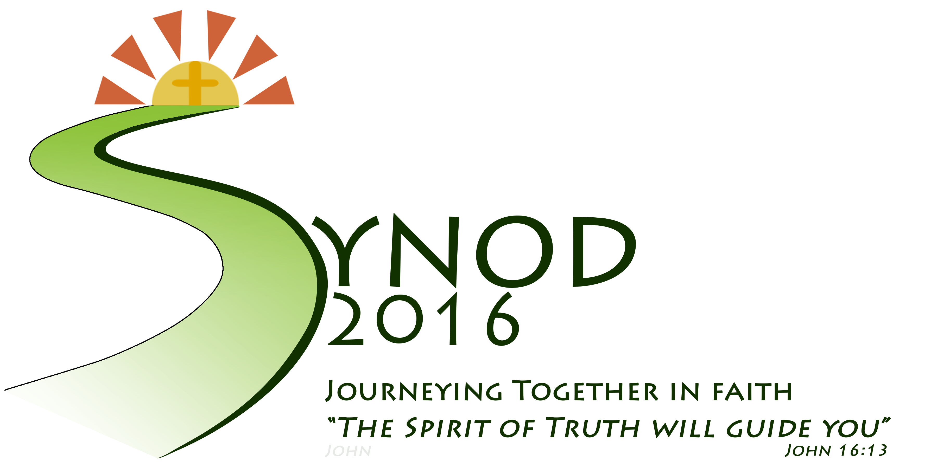

S

Y

N

O

D

Write an acrostic poem to describe the Limerick Diocesan Synod 2016. Your poem could even appear on the synod website! Please email: [synod2016@ldo.ie](mailto:synod2016@ldo.ie)

Acrostic Poem