Limerick Diocesan Synod 2016
Your Church, Your Voice
We need to hear from you - so have your say!

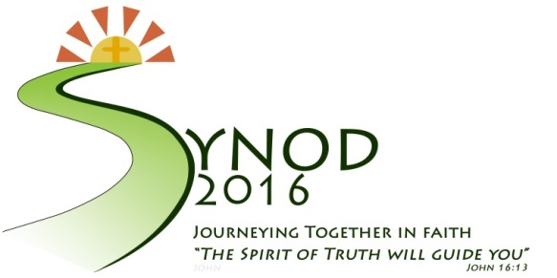

Log on to www.synod2016.com

The Limerick Diocesan Synod will take place in 2016 and will be the largest meeting ever held in the Limerick Diocese, bringing delegates together from every aspect of life throughout the diocese. It will be an opportunity to look towards the future of the Church in Limerick.

It is important that everyone has the opportunity to shape this future and influence what the Church will look like in Limerick in the years ahead. We need to hear from you so have your say.
The Limerick Diocesan Synod will take place in 2016 and will be the largest meeting ever held in the Limerick Diocese, bringing delegates together from every aspect of life throughout the diocese. It will be an opportunity to look towards
the future of the Church in Limerick.
It is important that everyone has the opportunity to shape this future and influence what the Church will look like in Limerick in the years ahead.
We need to hear from you so have your say.

REPORTING TEMPLATE FOR PARISH EVENTS

Parish/Community: _____________________________________________________

Model of Listening Used:
Large Assembly Small Group Focus Group

Informal Listening Other __________________________

Date: ______________ Numbers in attendance: __________

Brief description of particpants (e.g. ministry groups, youth group, young parents etc.):
_______________________________________________________________________
_______________________________________________________________________

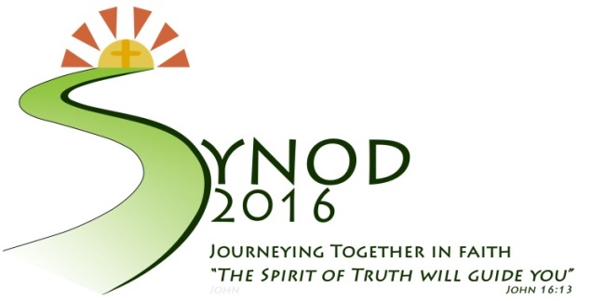

Log on to www.synod2016.com

Feedback Recorded on Discernement Questions:
- What are the topics that you would like to see on the agenda for the Limerick Diocesan Synod in 2016?

Please add additional pages as necessary

Log on to www.synod2016.com

- a) What is it that encourages you to participate in the life of your local Church?
Please add additional pages as necessary

b) What is it that you find difficult about participating in your local Church?
Please add additional pages as necessary

Log on to www.synod2016.com

- Where, in your everyday life, do you experience love, truth, goodness, hope and joy?

Please add additional pages as necessary

Thank you for your input; please log on to www.synod2016.com for ongoing information about the Synod

